**DAILY ONLINE ACTIVITIES SUMMARY**

|  |  |  |  |  |  |  |  |
| --- | --- | --- | --- | --- | --- | --- | --- |
| **Date:** | **13/06/2020** | | | | **Name:** | **Syed Rabeya Aamir** | |
| **Sem & Sec** | **8th B** | | | | **USN:** | **4AL16CS112** | |
| Online Test Summary | | | | | | | |
| **Subject** | | **IOT** | | | | | |
| **Max. Marks** | | **30** | | **Score** | | **30** | |
| Certification Course Summary | | | | | | | |
| **Course** | **Introduction to Amazon Sagemaker.** | | | | | | |
| **Certificate Provider** | | | **Aws** | **Duration** | | | **6 hrs** |
| Coding Challenges | | | | | | | |
| **Problem Statement:**  **1)** Python program to display all the prime numbers within an interval. | | | | | | | |
| **Status: Solved** | | | | | | | |
| **Uploaded the report in Github** | | | | **YES** | | | |
| **If yes Repository name** | | | | **rabeya** | | | |
| **Uploaded the report in slack** | | | | **YES** | | | |

**Online Test:**

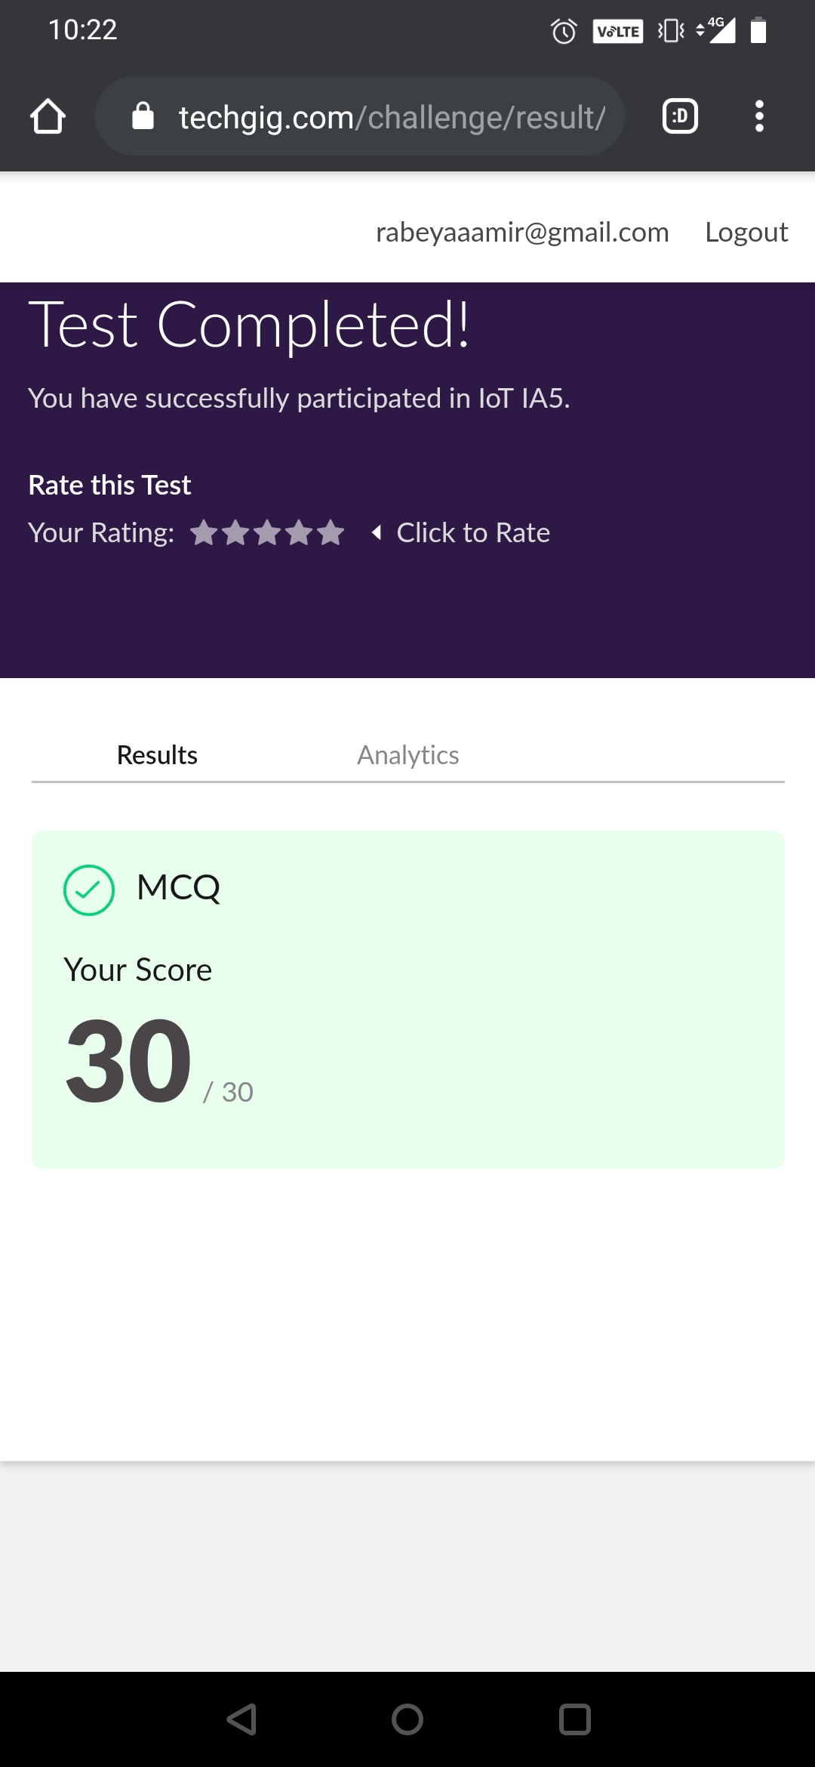

**Certification Course Details:**



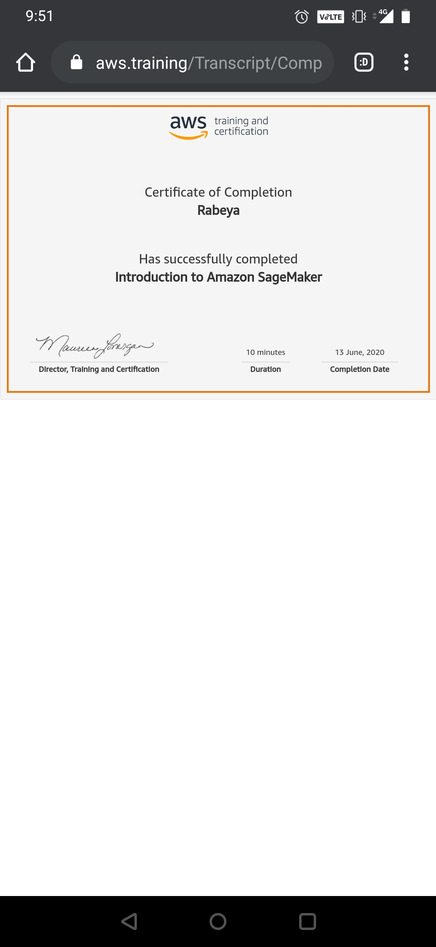

# CODE:

Program no:1

# Python program to display all the prime numbers within an interval

lower = 100

upper = 200

print("Prime numbers between", lower, "and", upper, "are:")

for num in range(lower, upper + 1):

if num > 1:

for i in range(2, num):

if (num % i) == 0:

break

else:

print(num)